Introduction of the Program
NSRCEL x SBI Foundation's I4B: iCube Cohort-3 Application Form
Last Date to apply: 20 Aug 2026 11:59:59 pm
Incubating Incubators Initiative (iCube)
NSRCEL x SBI Foundation's Innovators for Bharat
On National Start-up Day (16th January 2025), NSRCEL, IIM Bangalore, in partnership with SBI Foundation's Innovators for Bharat, launched the Incubating Incubators Initiative (iCube) to support emerging incubators in underserved areas. You can find our joint press release here.
Over the last year, we've gotten the opportunity to initiate our work with 5 incredible incubators across the country. You can find out about them along with other details about the program here: https://nsrcel.org/icube/
We now welcome applications for our next cohort of incubators: Based on the initial details you filled in, we think you could be a good fit for the program. Please do take some time to share with us more context so we can better understand your work and how we can support you.
Note: This is the 2nd of 3 rounds of the selection process. Applications will be reviewed on a rolling basis. So, we encourage interested incubators to express interest and apply at the earliest.

Draft
PART B: Tell us about your incubator
In the last stage, you'd share with us some details about the number, stage, and sectors of startups you support. Now, we'd like to understand more about the services you provide, your team, your partnerships, and your governance structure.

- What support does your incubator provide to the ventures? (select all that apply) *
- Mentoring & Coaching
- Peer / Cohort-based learning
- Programmatic learning
- Funding & Access to Grants
- Co-working Space
- Lab & Prototyping Facility
- Access to Markets & Funding Networks
- Access to Startup Services like Legal, Finance, etc

- Estimate what percentage (%) of ventures you support are operational and self-sustainable within 3 years of establishment? Please enter 0 if it is less than 3 years of setting up the incubator. *
Answer:O
- What according to you is the USP of your Incubator?
- Why do ventures come to you?
- If you're a new incubator, tell us why should ventures come to you? *
Answer:
Innovat Bharat Foundation is a new organisation, officially started about a month ago, but we have spent the last seven months understanding the rural entrepreneurship ecosystem.

Our USP is that we start before a venture even exists and support the journey from mindset to growth, specifically for rural and Tier-3 college students.

Phase 1 – Discover: We build an entrepreneurial mindset, help students identify real problems, explore ideas and form teams, from pre-ideation to ideation.

Phase 2 – Build: We support selected student entrepreneurs from ideation to prototype and connect them with established incubation centres.

Phase 3 – Grow: We help ventures access legal, finance, market and funding networks as they move towards growth.

Ventures should come to us because we provide a continuous pathway from mindset → idea → prototype → growth, while connecting rural entrepreneurs to the wider startup ecosystem.

- Tell us a little bit about your team (skip this question if you're yet to hire a team)?
Not filled
- Tell us about your current governance structure
  - This may include details like if you have a board, who sits on it, etc
  - This may also include mandates you have to fulfil as a function of your relationship with the host institution, the state nodal agency, etc *
Innovat Bharat Foundation is registered as a Section 8 company with two Directors who provide overall governance, strategic direction and operational leadership. Both Directors are actively involved full-time in building and executing the initiative.

We are also supported by a team of members and advisors from diverse backgrounds, including entrepreneurs, retired professors and software professionals. They provide guidance on entrepreneurship, education, technology, programme design and organisational development.

Our governance focuses on programme development, partnerships, financial and operational oversight, and alignment with our mission of promoting entrepreneurship among rural and Tier-3 college students.

We have developed an Entrepreneurship Development Program (EDP) for rural colleges and are currently in discussions with CBIT-Kolar, Shri Siddhartha Institute of Technology, Tumkur, and Dr. T. Thimmaiah Institute of Technology, KGF, to collaborate on its implementation.
PART C: Tell us about your incubation journey
- Please tell us about your context, vision, and mission. What is the gap in your region or institution that your institution aspires to fix?
Context & Gap:

In rural colleges, many students are curious about startups but do not know where to begin. They hear about incubators, hackathons and funding opportunities in big cities, but lack a structured path on campus to identify problems, develop ideas, find mentors and build solutions. As a result, rural talent remains underutilised, and the potential to create local jobs and solutions remains largely untapped.

Vision:

To transform Bharat into a global Product Nation by 2047, powered by a Bharat-centric economic model and 1 million (1 lakh?) rural entrepreneurs emerging from Tier-3 and rural colleges.

Mission:

We transform rural colleges into entrepreneurship hubs where students identify real problems, build solutions and create ventures. By enabling students to become entrepreneurs in their own towns, we aim to create opportunities, generate jobs and drive India's growth from the grassroots.

Please rate your incubator on the following aspects. Note that:
- Very Low- you don't do it at all
- Low - could mean that you're just starting out / you don't do it that well
- Medium- where you believe you're at par with incubators of your size in your context
- High - if you believe you do better than peer incubators but you still have things you want to be better on
- Very High- being the highest (you have overwhelming evidence that you're significantly better than peer incubators) *
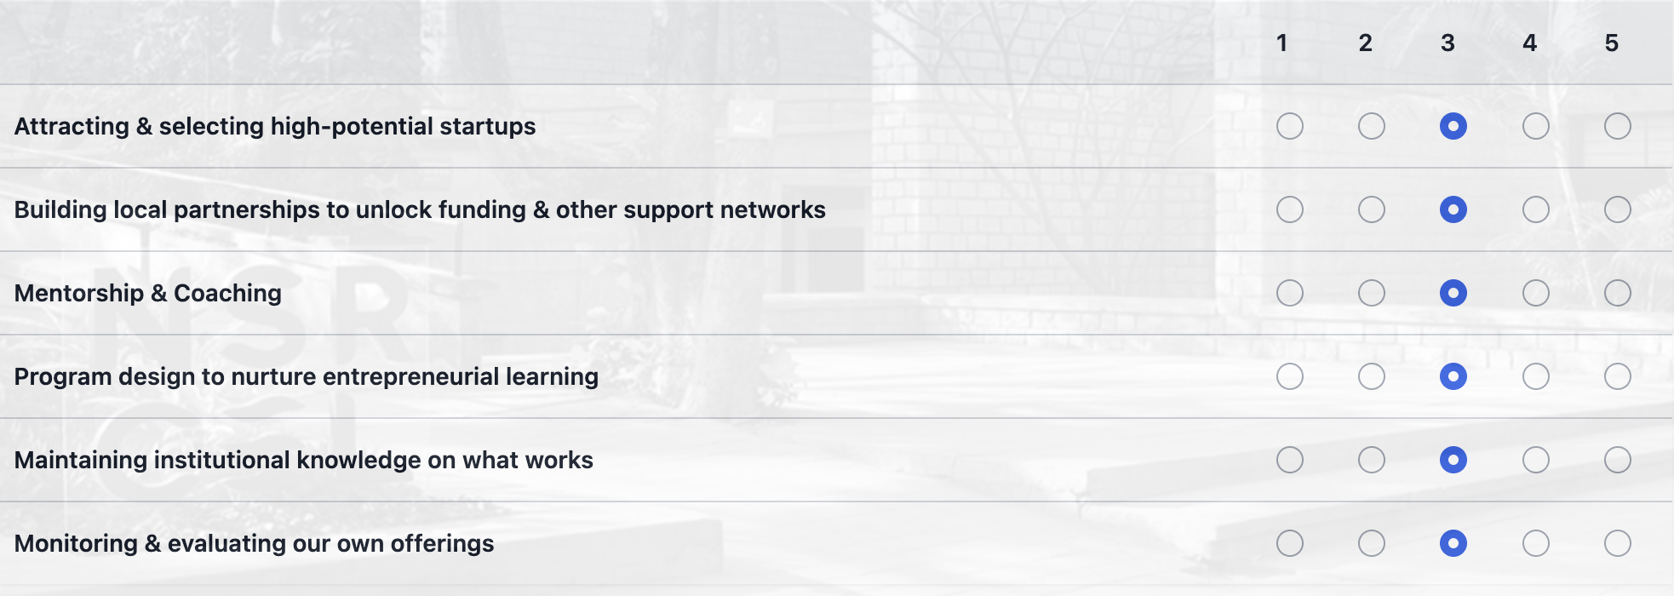
- Please mention your top 5 challenges
- Designing a strong program for students
- Executing the program effectively
- Making the organisation sustainable
- Minimal exposure to entrepreneurship within the Innovat Bharat team
- Building trust and credibility for Innovat Bharat among colleges and students

- Please mention your top 3 priorities in the coming year
- Complete Phase 1 of the Entrepreneurship Development Program in 20 colleges
- Establish two main revenue streams to ensure organizational sustainability
- Identify student volunteers and train them to execute the EDP.
- If you've interacted with NSRCEL Staff or Mentors about this particular program, please indicate their name
  - Sunil Maheswari

- Anything else you'd like to share with us?
A simple conversation with my niece made me think about the future of rural students. When I asked about her plans after engineering, she said, “I’ll get a software job,” as if there was no other option.

I realized this is not just one student’s mindset. Many rural students focus on marks, certificates and placements. Colleges often focus on theory, while the world needs practical skills, problem-solving, teamwork and innovation.

That’s why we started Innovat Bharat. We build entrepreneurship ecosystems in rural and Tier-3 colleges, helping students identify local problems, form teams, develop solutions and build ventures while they study.

Some ventures will succeed and create jobs. Others may not, but students will gain confidence, practical experience and an entrepreneurial mindset. We want rural students to become job creators who build opportunities in their communities and contribute to Bharat.

